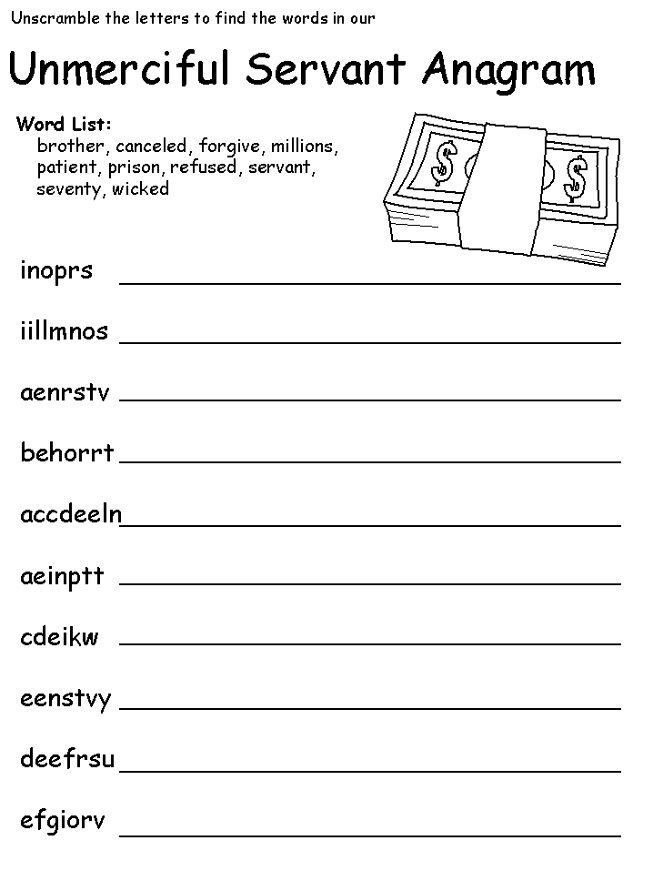
Source: http://www.dltk-bible.com/
Translation: Carolina von Scharten, London, Sir William Crookes Spiritist Society linked to BUSS - The British Union of Spiritist Societies.

