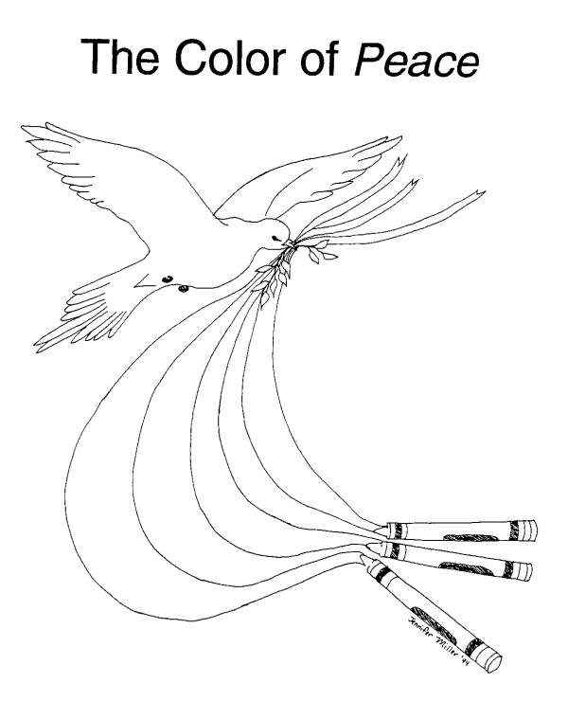

Source: The Peace and Justice Support Network (PJSN)

Activity sent us by Carolina von Scharten, London Sir William Crookes Spiritist Society linked to
BUSS - The British Union of Spiritist Societies.

