How to make an origami crane:

Start with a perfectly square sheet of paper.

Paper made specifically for origami can be found at most craft stores. It is usually coloured only on one side and comes in plain colours or beautiful patterns.

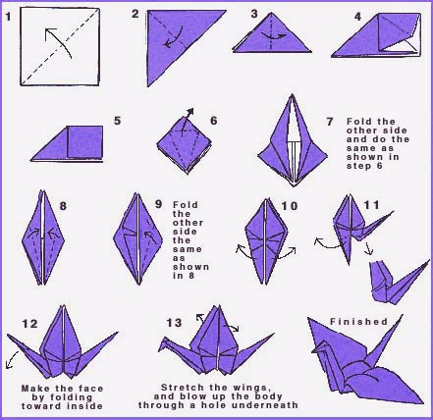

Source: origami.org.uk

Activity sent us by Carolina von Scharten, London Sir William Crookes Spiritist Society linked to
BUSS - The British Union of Spiritist Societies.

