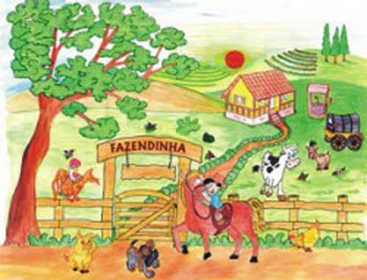
The little farm

Once upon a time there was a farmer who lived in a big farm. He had cows, chickens, ducks, pigs, dogs and cats in his farm. Every day he woke up, the first thing he did was to feed his animals. First, he fed the dogs and the cats. Soon later it was the time to go to the poultry yeard and offer corn to the chickens. He then walked towards the place where dugs, pigs and cows were located.
The farm was peace and quite until one day te cats decided to have a meeting. They were tired of being hurt by the dogs and decided to convince the ducks, chickens and cows that the dogs must be expelled from the farm.
The meeting started with a lot of confusion as the ducks, chickens, pigs, cats and dogs were talking all at the same time. They couldn’t understand each other. There was so much confusion around the meeting! The farmer decided that the dogs should sleep close to his house and the cats would be transfered to the cow stable, as they were making a lot of noise.
As the meeting finished, each animal went to a different direction; cows decided to drink water; ducks, pigs and chickens went to the field and the cats went to sleep. They were trying to forget about that confusion.
Therefore, something surprising happened...
The dogs felt sad as they were the one who cased the disuntion. They decided to ask the cats for their forgiveness. They first searched for the cows and mentioned their objectives, but the cows said the cats were full of pride and would not accept their forgiveness.
The dogs were determined to bring peace back to the farm and decided to talk to the pigs. Therefore, the pigs also adviced them not to speak to the cats. They said the dogs should enjoy living now close to the farm house.
The dogs then decided to talk to the chickens and ducks to hear their advices. They felt quite surprised with these animals’ views. Ducks and chickens had the opposite opinion from the pigs and cows. They said forgiveness would sort out the conflict and bring harmony to the animals.
The dogs then decided to find the cats and ask their forgiveness for all mistakes made. Cats were quite surprised but very happy to see the dogs’ attitude.
On that night, there was a big party at the cow stable where cows, pigs, ducks, chickens, dogs and cats celebrated peace!

