 Plurality of Worlds

1. Are all the globes that revolve in space inhabited?

Yes; and the people of the earth are far from being, as you suppose, the first in intelligence, goodness, and general development. There are many men having a high opinion of them who even imagine that your little globe alone, of all the countless myriads of globes around you, has the privilege of being inhabited by reasoning beings. They fancy that God has created the universe only for them.


God has peopled the globes of the universe with living beings, all of whom concur in working out the aims of His providence.

2. Is the physical constitution of all globes the same?

No; they do not at all resemble one another. 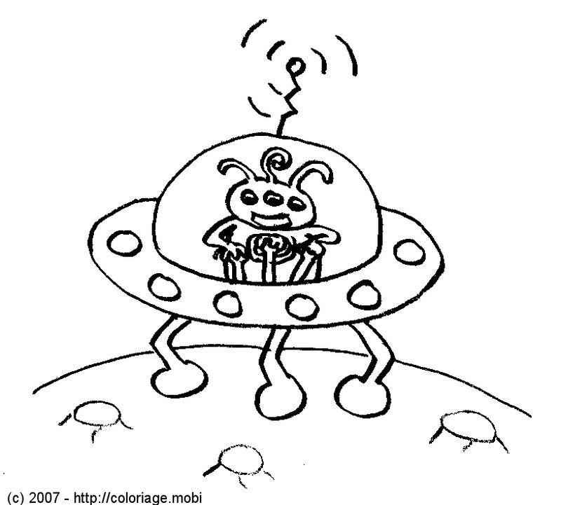

3. Since the physical constitution of the various worlds not being the same for all, does it follow that the beings that inhabit them have different organisations?

Undoubtedly it does; just as, in your world, fishes are organised for living in the water, and birds for living in the air.



4. Are the planets furthest removed from the sun stinted in light and heat, the sun only appearing to them of the size of one of the fixed stars?

There are other sources of light and heat than the sun. In certain worlds, the action of electricity plays a much more important part than in your earth. We need to remember that the beings of those worlds do not see in the same manner as you do. They might not the aid of organs such as yours.

The conditions of existence for the beings that inhabit the various worlds must be supposed to be appropriate to the sphere in which they are destined to live.

If we had never seen fishes, we should be at a loss to understand how any living beings could exist in the sea. So in regard to all the other worlds, they contain elements that are unknown to us. In our own earth, are not the long polar nights illumined by the electrical displays of the aurora borealis? It is possible that in certain worlds, electricity may be more abundant than in ours.

Those worlds may contain in themselves the sources of the heat and light required by their inhabitants.

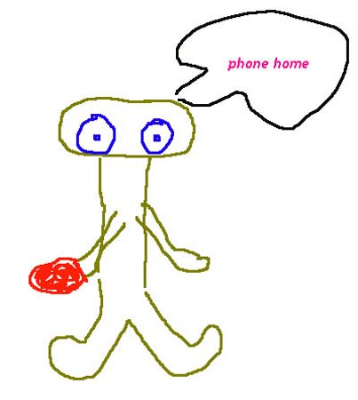

Incarnation in Different Worlds

1. Do we accomplish all our different corporeal existences upon this earth?
Not all of them, for those existences take place in many different worlds. The world in which you now are is neither the first nor the last of these, but is one of those that are the most material, and the furthest removed from perfection.

2. Does the soul, at each new corporeal existence, pass from one world to another or can it accomplish several existences on the same globe?

It may live many times on the same globe, if it be not sufficiently advanced to pass into a higher one.

3. We may, then, re-appear several times upon the earth?

Certainly.

4. Can we come back to it after having lived in other worlds? 

Assuredly you can; you may already have lived elsewhere as upon the earth.

5. Would it not be happier to remain as a spirit?

No, no! For this we should remain stationary; and we want to advance towards God.

6. Can spirits come to this world, for the first time, after having been incarnated in other worlds?

Yes; just as you may go into other ones. All the worlds of the universe are united by the bonds of solidarity; that which is not accomplished in one of them is accomplished in another.

7. Some of those who are now upon this earth are here, then, for the first time?

Many of them are so; and at various degrees of advancement.

8. Have the human beings who inhabit the other worlds bodies like ours?

They undoubtedly have bodies, because it is necessary for the spirit to be clothed with matter in order to act upon matter.

For in our Father's house are many mansions, and therefore many degrees among those mansions. There are some who know this, and possess the consciousness of this fact, while upon the earth; and there are others who have no such intuition.

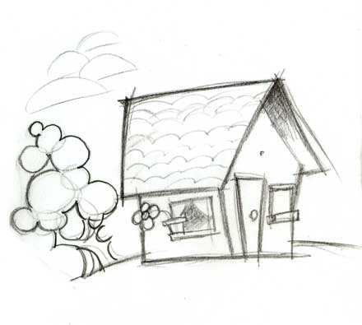

Independently from the diversity of the different worlds, the words of Jesus teach us that we should respect all creatures, no matter from what background, age group, and colour of the skin or place they are from. Let’s work together with our Master to be able to build a better world here and now.

Source:
THE SPIRITS’ BOOK – Questions 55 to 58, 172

