PRAYER
The prayer has three basic functions: to thank for everything we have received, to ask for things we wish to obtain, and to praise the greatness and kindness of God – our dear Father.
DRAW A PICTURE OF YOUR AND SHOW HOW YOU BECOME ENLIGHTENED WHEN YOU PRAY
THANK

ASK

PRAISE

PRAYER
Jesus taught us about the value and action of a prayer. When we pray we communicate with God, Jesus, our guardian spirit and all the good spirits who help us. A prayer can be very powerful when it comes from the bottom of our hearts.

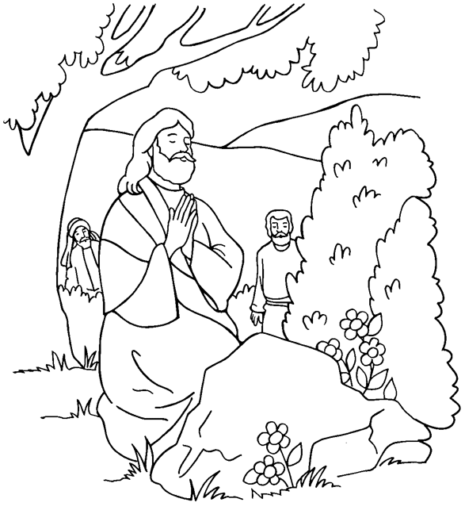
Activity sent us by Paula Melo, London, linked to BUSS - The British Union of Spiritist Societies.

