Name:
Date:

Colour and write down the three general characters of prayer:

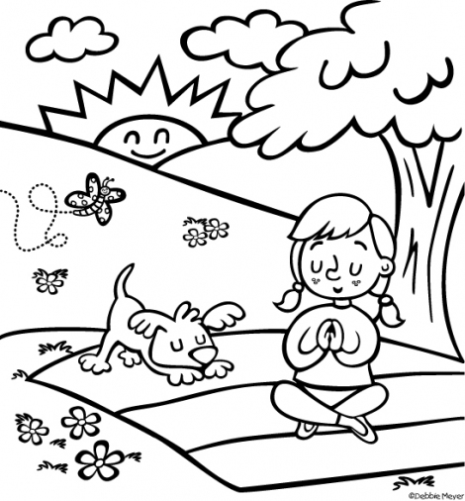

1....................................................................................
2....................................................................................
3....................................................................................

Activity sent us by Carolina von Scharten, London Sir William Crookes Spiritist Society linked to
BUSS - The British Union of Spiritist Societies.

