Name:
Date:

Colour and write down the three general characters of prayer:

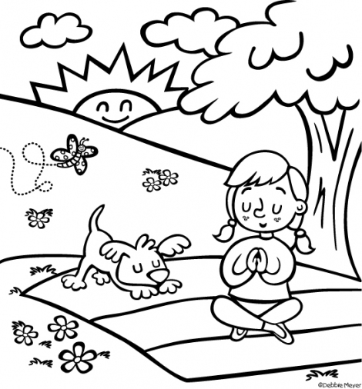
1....................................................................................
2....................................................................................
3....................................................................................

Answer:

The Spirits' Book by Allan Kardec - 659. What is the general character of prayer?

"Prayer is an act of adoration. To pray to God is to think of Him, to draw nearer to Him, to put one's self in communication with Him. He who prays may propose to himself three things: to praise, to ask, and to thank."

