The Lord's Prayer
Matthew 6:9-13 (NIV)

Jesus encouraged his followers to pray to God with sincerity and not for show. He gave them a simple outline of a prayer that has become known as the "Lord's Prayer". You can read it in Matthew 6:9-13 (NIV). He did not intend that we only use this prayer when we pray but that we would include some of the things in this prayer in our own prayers. This prayer shows reverence to God, dependency on God for our needs, desire for God's Kingdom to come, thankfulness, an awareness of our sins, a desire to be forgiven and to forgive others, and trust in God to lead us.

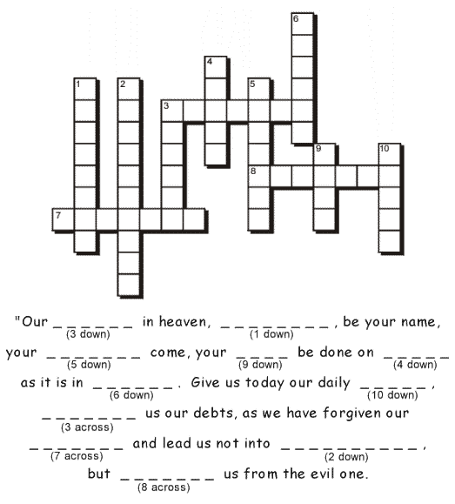
Source: http://www.ebibleteacher.com/children/lessons/prayer.htm

Activity sent us by Carolina von Scharten, London Sir William Crookes Spiritist Society linked to
BUSS - The British Union of Spiritist Societies.

