Name: _____________________________________________

When we pray, we connect with God. Circle the situations in which we can see God in our lives.

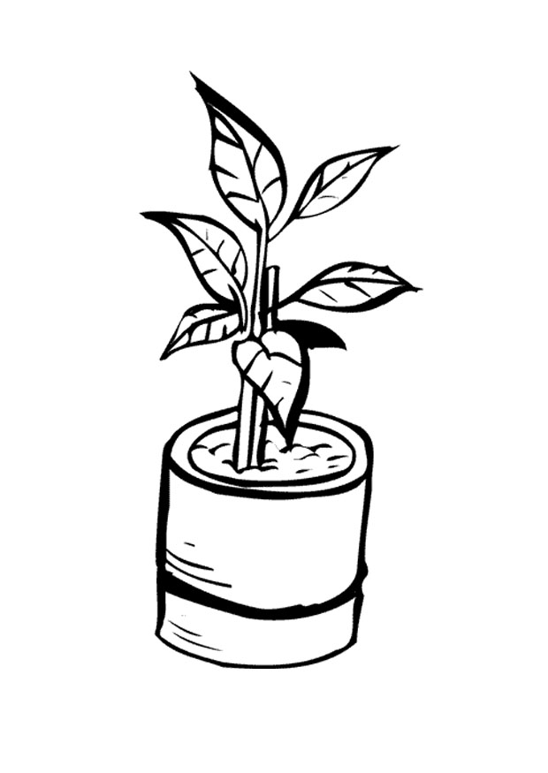

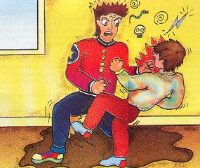



Images from the site: http://www.superkid.com.br and Revista Brasil Rotário

Activity received from Carolina von Scharten, London
Sir William Crookes Spiritist Society linked to
BUSS - The British Union of Spiritist Societies.

