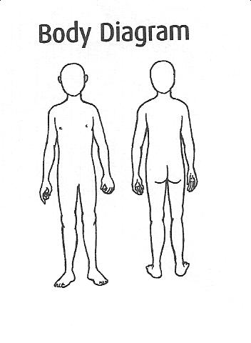
Record of existing injuries - Spiritist Centre XYZ
Confidentiality: make sure you use the cardboard flap to obscure any top copies that have been used.
Name of Child

Cause of injury

Description of injury

Teacher’s signature | Date | Time
Parent’s signature | Date | Time
Name of Child

Cause of injury

Description of injury

Teacher’s signature | Date | Time
Parent’s signature | Date | Time

