The Lord’s Prayer – Wikipedia

Popularity:

The Lord's Prayer, also known as the Our Father or Pater Noster, is perhaps the best-known prayer in Christianity.

English version:
“Our Father who art in heaven,
hallowed be thy name.
Thy kingdom come.
Thy will be done
on earth as it is in heaven.
Give us this day our daily bread,
and forgive us our trespasses,
as we forgive those who trespass against us,
and lead us not into temptation,
but deliver us from evil.
For thine is the kingdom,
and the power, and the glory,
for ever and ever.
Amen.”

Activities: See following pages.

- Please colour the picture below about Jesus and the “Sermon on the Mount”:
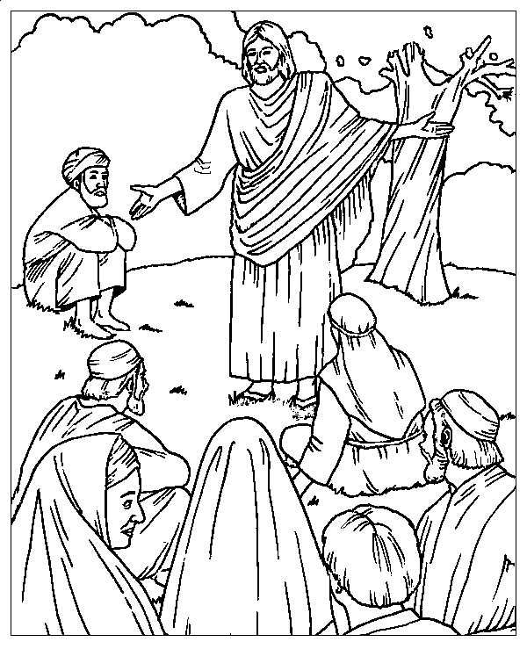

- According to what you have learned from the “Sermon on the Mount”, please write down in the blank road signs some good deeds you did during the past week so that you can achieve the end of the road:

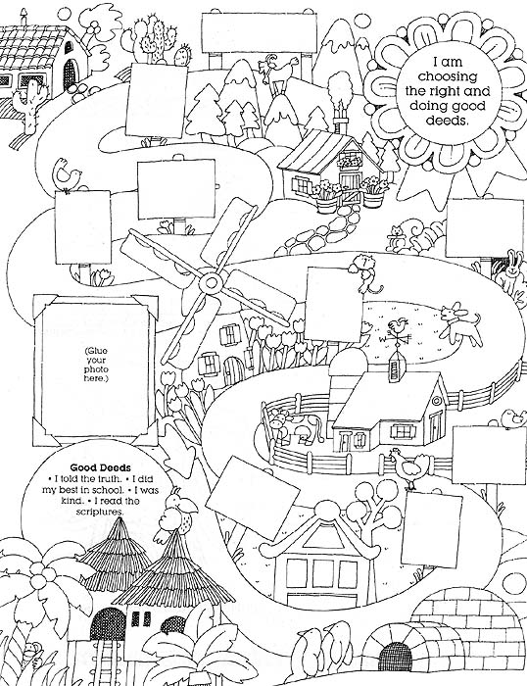

Activity sent us by Paula Melo, London, linked to BUSS - The British Union of Spiritist Societies.

