Suggested activity to be given as Homework:

Write in the spaces what you can do to help people.



Be _________________________in the queue and wait for your time.
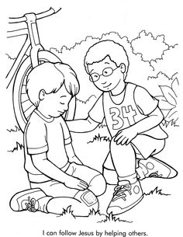

Give a _________________________to our friend in need.

Take ____________________ of the old dear ones with love.

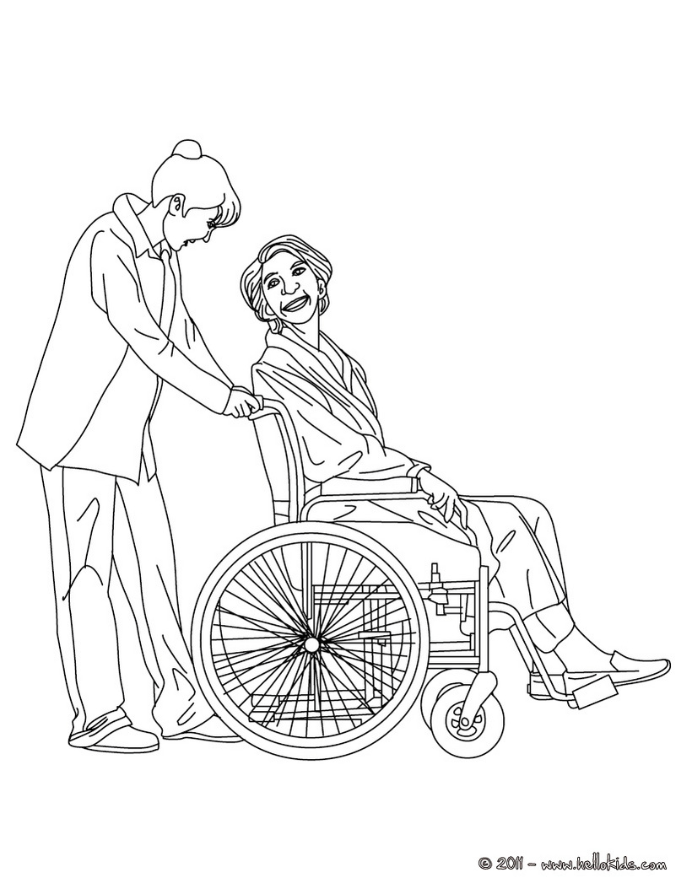
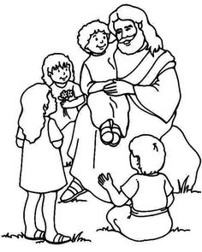

I __________________________ our dear Jesus.

