The fruit of Spirit
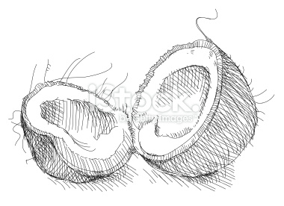
Love

The fruit of Spirit is not a coconut/banana/watermelon…
If you want to be a coconut/banana/watermelon…
You might as well hear it
You can’t be a fruit of Spirit
Because a fruit o Spirit is
Love
Joy
Peace
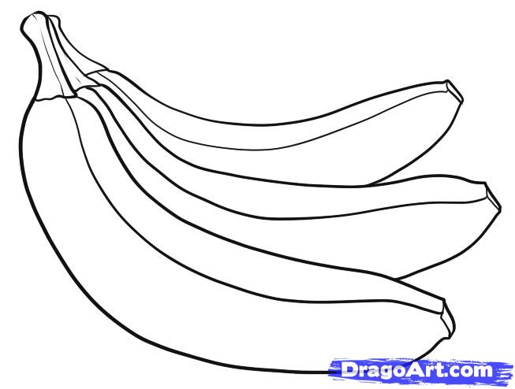

Joy
Patience
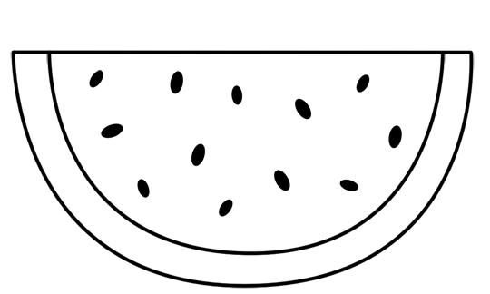

Peace
Kindness
Goodness
Faithfulness
Self-Control


Patience


Kindness
Kindness
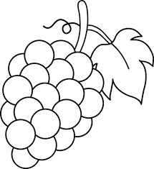
Goodness

Faithfulness

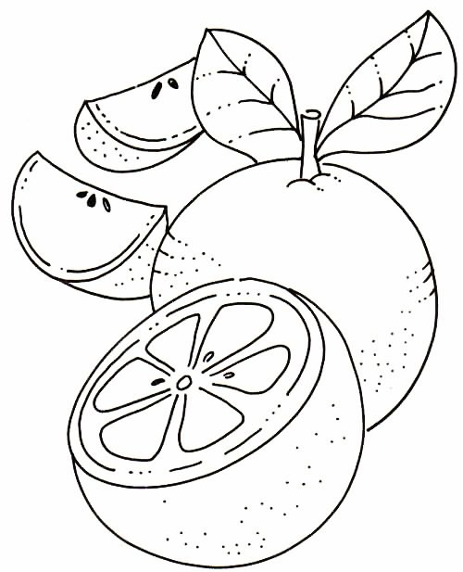

Self- Control

