THE CHILD
Man will build his nest on the top of the highest buildings made of concrete...
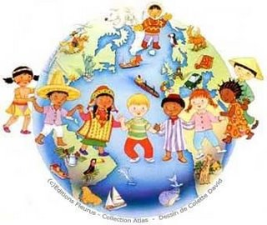
He will dominate science and will fill the space above with multiple invisible waves transmitting sound and colour...
He will cross the sky in flying palaces at the speed of lightning...
He will tower over powerful instruments to study the nature and the movement of the stars...
He will reach in triumph the top of intellectual conquests speculating about the essence of the universe...
However, if he does not come down to help the child lying on the floor of the world, it will be useless to hope for a better Mankind.
It is during childhood that the germ of perfection appears renewed, in the same way that the brightness of a new day begins at dawn.
Stretch out your generous arms and help the little ones who are around you.
Free them today from ignorance and poverty, laziness and cruelty, so that tomorrow they may be able to avoid crime and suffering.
Be it flesh from your flesh or someone else’s offspring, every child is the life of your life.
Learn how to kneel down to reach it in the same way Jesus came down to redeem us.
If we fail to rescue childhood for the glory of God, all human progress will continue to oscillate over the thorn bushes of illusion and evil.
Do not forget that by each cradle God allows us to meet our own future.
It is in our hands to transform it into a dangerous path leading to darkness or a bright stairway leading us to the light.
EMMANUEL
(Medium: Francisco Cândido Xavier, in: “Taça de Luz” – LAKE Edition)

