Please link the image to its description

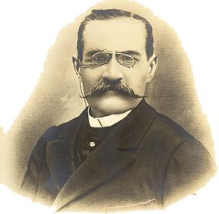

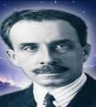

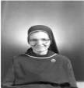

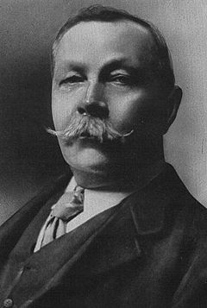

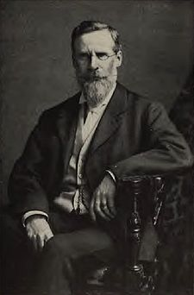

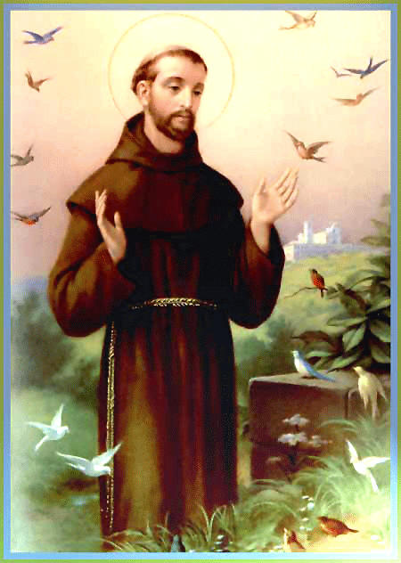

Sister Scheilla was born in Germany. She was a nurse and aided victims during the Second World War. She died in July of 1943 during a violent air raid. She was born in Dijon on January 28, 1572 and died in Moulin on December13, 1641. The Spirit of sister Scheilla is particularly known for attendance on sick people.

Sir Arthur Ignatius Conan Doyle (22 May 1859 – 7 July 1930) was a Scottish physician and writer, most noted for his stories about the detective Sherlock Holmes, which are generally considered a major innovation in the field of crime fiction, and for the adventures of Professor Challenger. In 1916 Arthur Conan Doyle made a declaration that would impact the rest of his life. He stated his belief in Spiritualism. Sir Arthur Ignatius Conan Doyle supported Spiritualism and its scientific proof of existence beyond the grave. In particular he favoured Christian Spiritualism, and encouraged the Spiritualists' National Union to accept an eighth precept, that of following the teachings and example of Jesus of Nazareth.

Sir William Crookes, (17 June 1832 – 4 April 1919) was a chemist and physicist who attended the Royal College of Chemistry, in London, and worked on spectroscopy. In 1870 Crookes decided that science had a duty to study preternatural phenomena associated with Spiritism. The experiments that made him really famous were with the medium Florence Cook, at the time, only a teenager. Through her mediumship, there occurred a series of materializations of the Spirit Katie King, which lasted almost three years.

Saint Francis of Assisi (Giovanni Francesco di Bernardone; 1181/1182 – October 3, 1226) was a Catholic deacon and the founder of the Order of Friars Minor, more commonly known as the Franciscans. He is known as the patron saint of animals and the environment.

Léon Denis (January 1, 1846 - March 12, 1927) was the consolidator of Spiritism. He was not just the substitute and continuator of Allan Kardec, as is generally supposed. Denis had a mission practically as significant as the one of the Codifier. To him, was assigned the development of the doctrinaire studies, to proceed with the mediumistic research, to propel the Spiritist Movement in France and all over the world, to deepen the moral aspect of the Doctrine and above all, to consolidate it in the first decades of the Century.

André Luis is not his real name and very little is known about him. All that is known is that he worked as a doctor in Rio de Janeiro in the early 20th century. He revealed a rich and vast contribution from the spiritual domain and several books of his books were psycho graphed by Francisco Candido Xavier. His first and most famous book was "O Nosso Lar", translated into English as the "Astral City", which was published in 1944.

Activity sent us us by Carolina von Scharten, London
Sir William Crookes Spiritist Society linked to
BUSS - The British Union of Spiritist Societies.

