Please link the image to its description

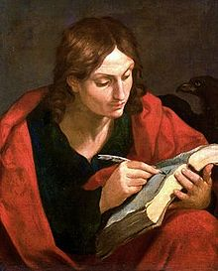

You won’t be able to find my picture very easily. Who am I?

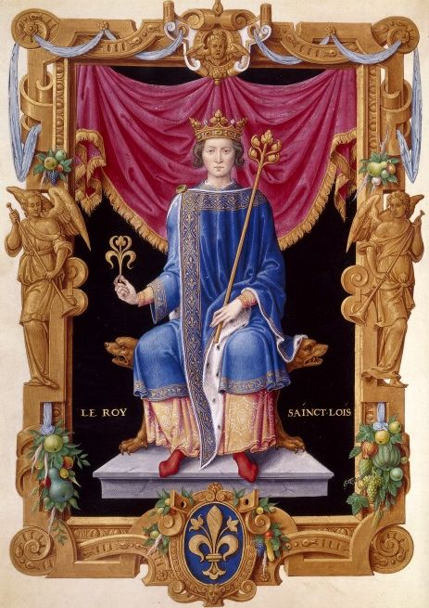

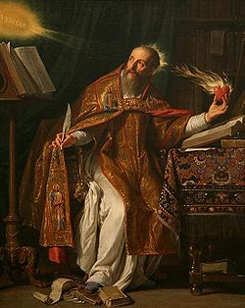

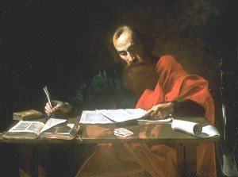

JOHN THE EVANGELIST - The Apostle of Jesus Christ, son of Zebedee and brother to the Apostle James. He was the author of the fourth Gospel and three epistles. While exiled on the Greek island of Patmos he received, through the means of mediumship, the Apocalypse. He lived almost one hundred years. Together with the Apostles Peter and James the Elder, he was invariably called upon by Jesus to witness the most important events which occurred during His mission.

SAINT LOUIS (Louis IX) - A King of France, he lived from 1215 until 1270. He began his reign under the tutorship of his mother, Blanche de Castille. He took part in the seventh and eighth
Crusades and discarnated as a victim of a plague on disembarking in Cartagus. He was a good and pious man and was cannonised by the Catholic Church in 1297. He is constantly cited in the Revue Spirite thanks to the numerous communications received from his Spirit.

PAUL, THE APOSTLE - Born in the flourishing town of Tarsus in Cilicia, possibly in the year 10 or 12 of this epoch; he was martyrized in Rome in the year 67 AD. Nicknamed 'The Apostle of the Gentiles,' he was one of the most outstanding disseminators of Christian ideas, taking the word of Jesus Christ to the great centres of population of that time, these being Antioch, Athens, Ephesus, Corinth, Macedonia, Jerusalem and Rome. He wrote a great number of Epistles, which are contained in the book of 'The Acts of the Apostles' where many elucidative descriptions of his Apostlehood and his incomparable activities in favour of the birth of Christianity are also to be found. His original name was Saul, which was later changed to Paul. Although he was not one of the Apostles of Jesus he deserves the title of Apostle due to the magnificent tasks which he accomplished.

SAINT AUGUSTIN, (Aurelius Augustinus, 354-430 AD) - Bishop of Hipona, he was a theologist, philosopher, moralist and dialectician. After a disturbed boyhood he was attracted to a religious life by the Spirit of the enlightened Ambrose. On the insistence of his mother, Monica, he left Africa to go to Italy hoping to seek a more promising career in the Roman Empire. He wrote many sermons, helped the poor and, during the second part of his life, maintained the firm objective of serving the Church and Christ He became the most celebrated of all the doctors of the Catholic Church. He sought to harmonize the doctrine of Plato with the Catholic dogmas, and intelligence with faith. His chief works were "The City of God," "Confessions" and a treatise on grace.

ERASTUS (A disciple of Paul) - Treasurer of Corinth, he was a disciple of Paul of Tarsus, having accompanied him on his mission to Ephesus. He is cited in the book of Acts, 19:22. - "So he sent into Macedonia two of them that ministered unto him, Timotheus and Erastus; but he himself stayed in Asia for a season. 'In the book of Romans, 16:23. - "Gaius mine host, and of the whole church, saluteth you. Erastus the chamberlain of the city saluteth you, and Quartus a brother." In 2 Timothy, 4:20. - "Erastus abode at Corinth: but Trophimus have I left at Miletum sick."

Activity sent us by Carolina von Scharten, London
Sir William Crookes Spiritist Society linked to
BUSS - The British Union of Spiritist Societies.

