Homework: Who is my family

Jesus said to honour our mum and our dad.
How amazing and grateful is to have a family!
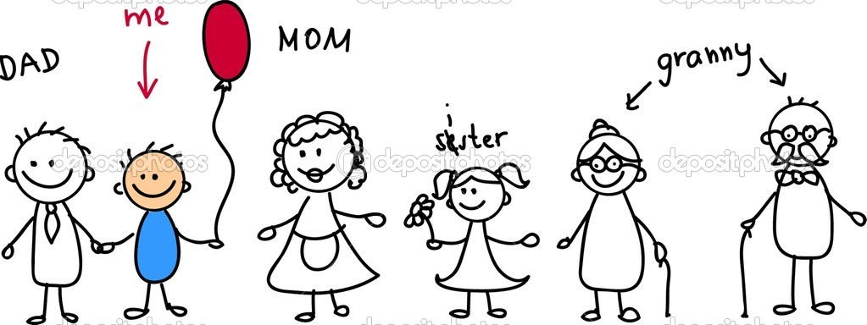

Now show us our beautiful family! A Gift from God to you!

