- The Spiritist Centre and the Education of Children and Youth
The Spiritist Education for Children and Youth is the best way for the Spiritist Center to accomplish one of Spiritism’s main purposes: to transform everyone into good human beings, because the Spiritist Education for Children and Youth is one of the first activities that serve as basis to the moral building of a New World.
The Spiritist Center aware of its mission should make every effort not only to the creation of the Spiritist Education for Children and Youth, but also for its full operation, considering its importance regarding the moral preparation of the new generations and the preparation of future practitioners of the Spiritist Center and the Spiritist Movement.

- Teaching Program
A teaching program containing evangelic moral is the key element utilized in the preparation of our classes. This knowledge is brought to the students through practical situations of life. The methodology employed has as aim to inspire the students to reflect by themselves and to reach their own conclusions regarding the subjects studied, because this is the only effective way to promote real learning.
The curriculum utilized during the classes of Spiritist Education has its content based on the works of the Spiritist Codification and it constitutes a course of Spiritism, which develops during the process of the Spiritist Education.
Source:. Curriculum for Spiritist Education for Children and Youth – Brazilian Spiritist Federation/ Education according to Spiritism, Dora Incontri/Concept and Philosophy of Education – Brazilian Spiritist Federation / Education for the Spirit – Walter Oliveira Alves
claudiawerdine@hotmail.com

What is Spiritist Education?

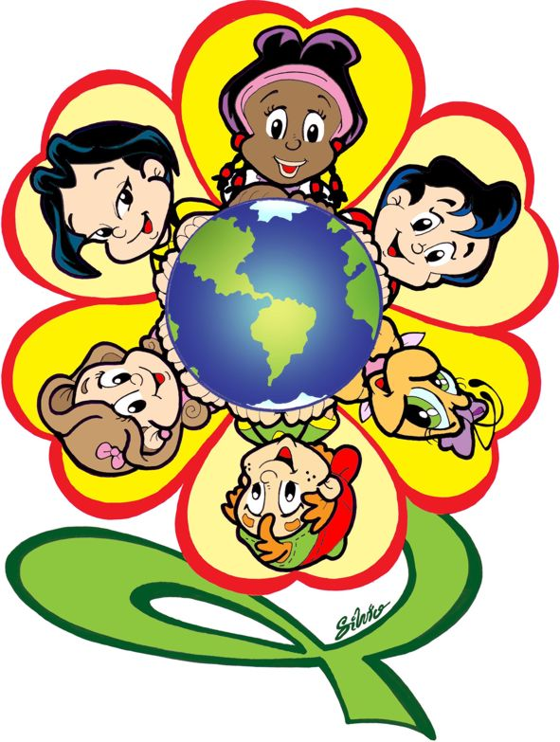
CONSELHO ESPIRITA HOLANDES

- Conceito
O que se faz na área da infância e juventude sob a denominação de Evangelização Espírita Infanto-Juvenil é a difusão do conhecimento espírita e da moral evangélica pregada por Jesus, que foi apontado pelos Espíritos Superiores, que trabalharam na Codificação, como modelo de perfeição para toda a Humanidade.
Como a preocupação não é somente com a transmissão de conhecimentos, mas sobretudo com a formação moral; e como a formação moral se inspira no Evangelho, pareceu mais apropriada a denominação da Evangelização Espírita dada a esta tarefa, por expressar, na sua abrangência, exatamente o que se realiza em nossos grupamentos de crianças e jovens.

- Objetivos:
- Promover a integração do evangelizando: consigo mesmo, com o próximo e com Deus;

- Proporcionar ao evangelizando o estudo: da lei natural que rege o Universo; da “natureza, origem e destino dos Espíritos, bem como de suas relações com o mundo corporal”;

- Oferecer ao evangelizando a oportunidade de perceber-se como: ser integral, crítico, participativo, herdeiro de si mesmo, cidadão do Universo, agente de transformação de seu meio, rumo a toda perfeição de que é suscetível.

“A Spiritually Educated Child – will be an adult that will raise oneself toward future happiness.”
Bezzera de Menezes

boundaries, that reveals broader horizons, which meets the e
- 1. Concept
What is accomplished in the area of children and youth under the name of Spiritist Education is the dissemination of the Spiritist knowledge and the moral teachings given by Jesus, who was appointed by the Superiors Spirits that worked on the codification, as a model of perfection for the whole Humanity.
As the concern is not only with the passing on of knowledge, but mainly with the moral formation, and as the moral formation is based on the Gospel, it seemed more appropriate the denomination of Spiritist Education, as it comprises exactly what takes place during our group meetings.
- 2. Objectives:
- Promoting the integration of the student: with oneself, with God and with others;
- Providing to the student the study of: the natural law that governs the universe; the nature, origin and destination of the spirits, as well as its relationship with the corporeal world.
- Offer to the students the opportunity to understand themselves as: an integral being, critical, participative, heir of oneself, citizen of the universe, agent of the transformation of one’s environment, towards the whole perfection one can achieve.

- 3. Spiritism and Education
Spiritism is an eminently rational set of knowledge, and possesses strong resources to enlighten the education with a philosophy that transcends all the immediate material needs, that transcends all boundaries, that reveals broader horizons, which meets the most noble interests, and that has an ideal capable of boosting real progress.

From the spiritist point of view, education starts before birth and continues after the death of the physical body.
“It is through Education, even more than by Instruction that Humanity will be transformed."
Allan Kardec, The Spirits' Book

4. Importance of the Spiritist Education
The main purpose of a Spirit to return to a body of a child is to be educated again. The positive impressions the Spirit receives during childhood may be crucial to its current existence and even to future lives. It is because of the semi-conscious state of the incarnate spirit in a child’s body that its mental barriers of defense are neutralized, thus it is softer and more receptive, as well as more flexible and open to all influences ...
Hence, the importance of the Spiritist Education, because to spiritually educate the children is to prepare them to face all times and all adversities of life according to the postulates of the Gospel. It is the only way to cultivate in the spirit of the child, since the dawn of life, the understanding of practicing good deeds, the acquisition of morality and knowledge, so that it may reach the twilight of its physical existence conscious of its spiritual achievements, knowing itself and placing itself in the universe as a collaborator of the Supreme Divinity.

