Who is my family

Jesus said to honour our mum and our dad.
How amazing and grateful is to have a family.
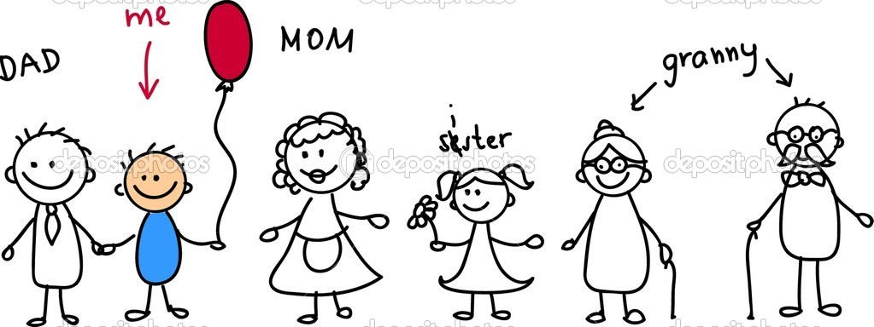

Now show us our beautiful family!

